  - Network Types
  - Key Revision Facts: GCSE Computer Science

LAN
A LAN (local area network) is a network of computers within the same building, such as a school, home or business. A LAN is not necessarily connected to the internet.
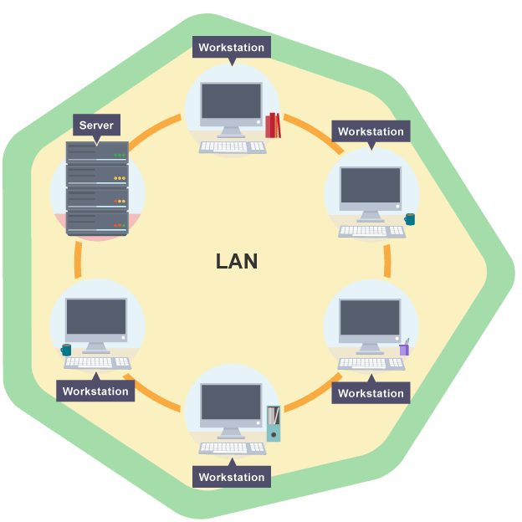

WAN
A WAN (wide area network) is created when LANs are connected. This requires media such as broadband cables, and can connect up organisations based in different geographical places. The internet is a WAN.
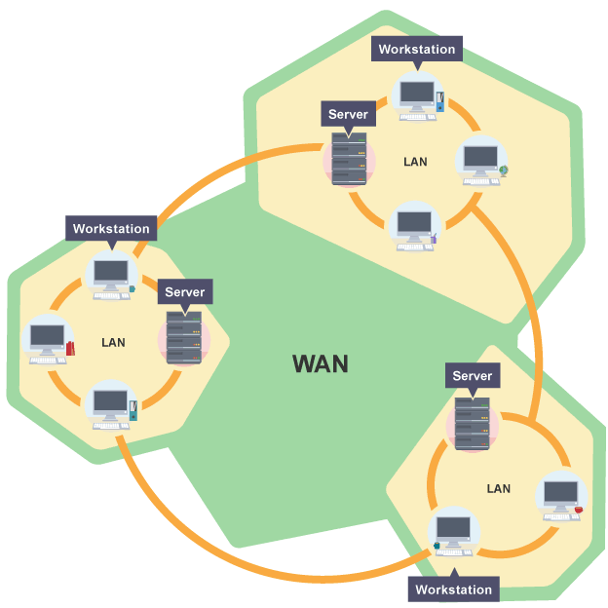
VPN
A VPN (virtual private network) is usually hosted securely on another network, such as the internet, to provide connectivity. VPNs are often used when working on secure information held by a company or school.

